**Assignment – 2**

**Student** (*snum*: integer, *sname*: string, *major*: string, *slevel*: string, *age*: integer)

First execute the DB.sql script (provided with the assignment) to create the tables and insert data.

**Task [total 10 marks]:**

1. [4 marks] Create a PL/SQL **function** that takes a student number as a parameter and returns the number of students of the same age.
2. [4 marks] Create a table as following schema –

**age_info** (*trackid:* integer*, snum:* integer, *same_age:* number)

Now, create a PL/SQL **procedure** that –

* 1. Takes track id variable as a parameter.
  2. Uses the function created in part – 1 in selection operation and stores the results into a cursor.
  3. Increments track id by 1 and inserts into **age_info** table along with the student numbers and corresponding number of students of the same age (fetched from the cursor).

1. [2 marks] Create a PL/SQL **anonymous block** that invokes the procedure created in – 2 with an initial track id.

**Sample output:**

For track id 1000 -

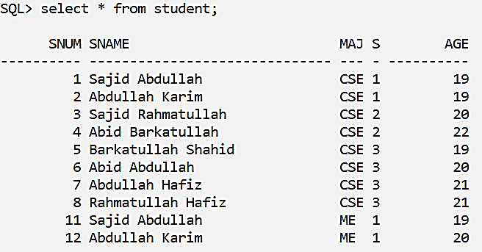 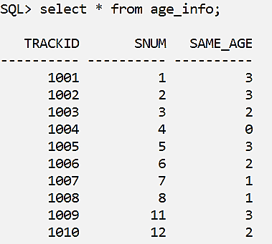

**Note:** Bring the solutions in three different scripts for function, procedure and anonymous block. Put your name, id and group at the top of each script within comments. Bring both the printed and soft copy with you.